8.3 Interactive Modules:
Go to www.classzone.com and click on HS Science, State, and 2010 Book. Then click on Animations. Follow photo below.
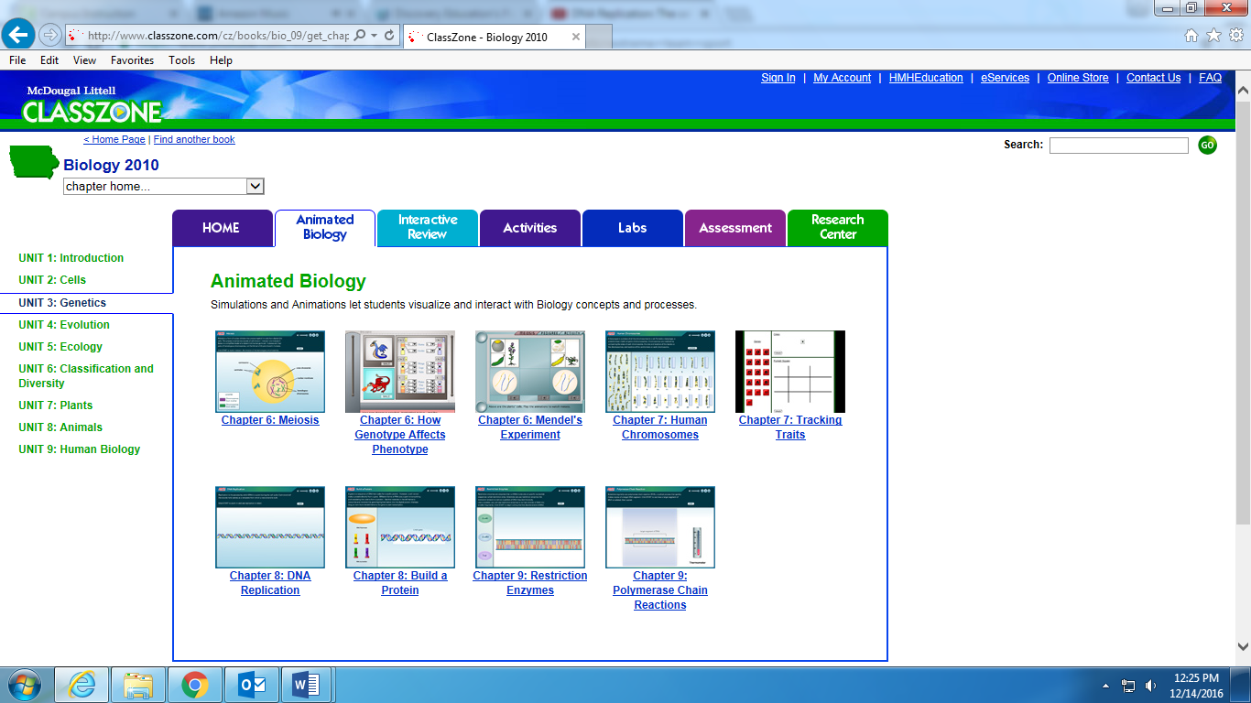
Do this one.
Click on link in electronic Menu
